Drivers of Rates and FX volatility -- macro, fundamental, technical, and idiosyncratic.

How do we measure market volatility? Look at implied volatility across different markets: VIX, JPM FX Vol Index, EUR Swaption vol, USD Swaption vol over some time period -- say 1990 to present. Then look at the percentile that current volatility falls under.

Key drivers:

- Macroeconomic volatility -- economic surprises
- Central bank monetary policy and communication
- Political surprises that drive economic activity
- Leverage (acting as an amplifier)

Macroeconomic volatility
Track this using global real growth and the volatility of quarterly global GDP growth. Also, inflation volatility. For example, use 3y rolling SDs of q/q annualized global growth GDP.

Steady declines in growth volatility and muted inflation volatility mean that there are fewer realized macro surprises that could trigger sharp rises in financial market vol.

Global growth volatility can be decomposed into the average volatility of GDP growth across countries and the correlation of GDP growth across countries and regions. The latter measures the degree to which growth shocks have been systematic or idiosyncratic.

Macroeconomic shocks affect financial market volatility -- holders of risky assets should only be compensated for systematic, undiversifiable risk, which from a fundamental perspective should be linked to uncertainty/volatility of growth and inflation. The link from macro to rate vol is quite direct -- they both price the expected path of future real rates and inflation along with term premia around both.

Central Bank Monetary Policy and Communication
Central banking balance sheets tend to muffle liquidity.

Post-crisis, central banks continue to use forward guidance but at horizons that are significantly longer than pre-crisis.

Politics
Political events can trigger policy shifts and also in principle trigger rises in financial market volatility

Leverage
Leverage can amplify the impact of a shock of a given magnitude.

Market Pricing (as of July 2017)
While there has been chatter about elevated uncertainty that is not fully reflected in risk premia this is in conflict with the fact that macroeconomic volatility has kept grinding lower. This is turn means that part of financial market vol that is driven by this underlying fundamental volatility should also be commensurately lower in the absence of new shocks. And, when shocks do occur, easy liquidity conditions and less vulnerable balance sheets have suppressed transmission.

Even if implied and realized volatility are at very low levels, the ratio of implied to realized volatility is relatively close to long-term averages. This makes it difficult to argue that rates volatility is particularly underpriced.

On the USD IR volatility side, we are in the middle of structural shift that has been taking place post-crisis. The MBS market through the GSEs was a reliable source of demand for USD IR volatility for those looking to take exposure to the MBS basis by hedging out duration and convexity using IR derivatives (“OAS traders”). As GSEs’ retained portfolio have shrunk, they’ve been reabsorbed by comparatively non-active hedges such as Fed, banks, asset managers, and foreign investors.

In principle, cessation of reinvestments by the Fed and return of these exposures to the private market is a bid for vol. However, the question is whether the investors who take down this supply will hedge vol or not. GSEs retained portfolios are still decreasing while REITs do not hedge a significant fraction of negative convexity in their holdings.

1. Passive Investors Rule
As investors woke up to how hard it was for money managers to consistently beat benchmark indexes, they also started to get allergic to their fees. So, index-trackers and exchange-traded funds have soared in popularity. Case in point: Vanguard’s Total Bond Market Index fund went all tortoise versus hare with Pimco Total Return Fund, the fund where Gross made his name as the bond king. The Vanguard fund, which seeks to match the performance of a benchmark index, in 2015 overtook the actively managed Pimco offering -- which strives to beat its benchmark -- to become the world’s biggest bond fund.
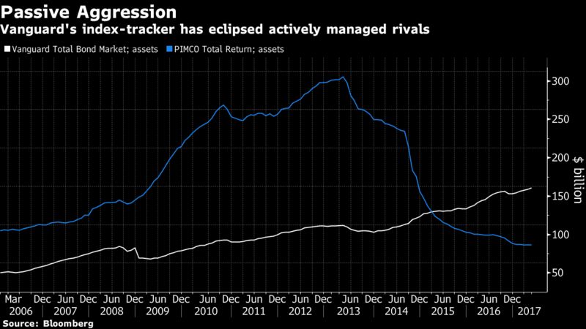
This sort of trend -- replicated across asset classes -- theoretically means a lot of the buying and selling of securities becomes more predictable.

2. Rev-it-up Regulators
Since the near-death experience of the financial system in 2008-09, regulators worldwide have moved to strengthen curbs on behavior they viewed as risky by the largest financial institutions. From big measures to small, that’s meant the banks and insurance companies that had often sought to turn large piles of cash into enhanced revenue streams by investing in all manner of higher-risk securities no longer do as much of that -- causing volatility to drop. Read the strange tale of South Korean callable bonds for just one example.
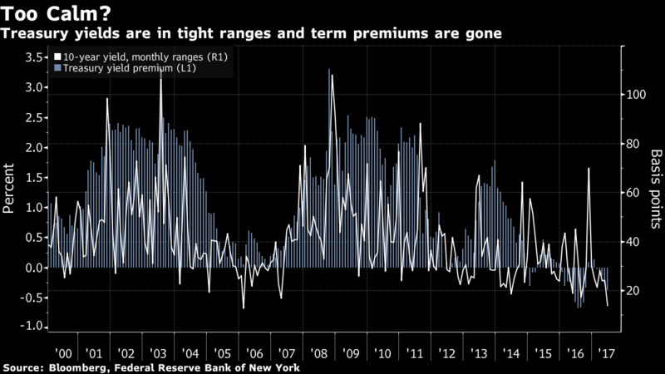
In the process, the regulators have helped make investors so eager to hold U.S. Treasury securities that the term premium has gone negative -- meaning they are foregoing any extra compensation for the risk involved in buying longer-term securities rather than shorter-term ones.

3. Low Interest Rates
Never before has so much money been lent to so many at such low rates. The yield on the Bloomberg Barclays Global Aggregate Index dropped to an unprecedented 1.07 percent in 2016 and was recently at 1.53 percent -- compared with a 9.6 percent high in 1990, soon after its inception -- and an average since then of 3.3 percent. That’s propelled investors into other, riskier, assets, boosting their prices and in turn reducing volatility. Look no further than serial defaulter Argentina managing to sell a century bond this month.

4. Rise of the Machines
Increasing use of automation and computer-run algorithmic trading has transformed global markets. Because machines are able to swiftly address any anomalies in valuations, they promote more efficient price discovery -- or so the thinking goes -- and that means fewer and smaller swings in price before equilibrium is found. Confidence in algorithms might also have diminished investor demand for options, leaving their prices lower and bringing down volatility gauges along with them.

5. Mean Reversion?
A decade after the global financial crisis erupted, markets might just be getting back to an “old normal.” With solid -- if unspectacular -- economic growth rates and contained inflation, there’s little reason for asset prices to swing dramatically. The S&P 500 index has now gone more than six months without a one-day drop exceeding 2 percent -- the longest such stretch in a decade. That still pales in comparison with the 42-month run that ended in February 2007.

6. Quantitative Easing
Major central banks might have put a floor under global asset prices with their unprecedented balance-sheet expansions over the past decade. While the Fed’s assets topped out years ago and are now poised to fall, the Bank of Japan and European Central Bank are still accumulating securities.
This list doesn’t incorporate all the theories for low volatility, with even social media being assigned some role -- read more about that here. Which of the explanations proves most accurate may not be known until volatility returns.
Looming shifts toward central bank balance-sheet contraction would seem to have as good a chance as any other events to bring about a sea change. As the final chart below shows, the decision by the world’s three biggest monetary authorities to swell their combined balance sheets to almost $14 trillion has helped pump up stock and bond prices -- raising questions about what happens on the way down.

